**Commodore 1541 VIA/Parallel-Adapter for 1541C Rev. 0**

**Testing**

# Test Setup

* VIA/Parallel-Adapter for 1541C Rev. 0
* 1541C (not operational) for mechanical testing
* 1541 with SpeedDOS Kernal v2.7
* C64 with SpeedDOS v2.7
* User Port Parallel Adapter for the 1541/1541-II Rev. 0

# Test Execution

The Parallel Adapter for the Commodore 1541C was installed in a 1541C. It has fit without a problem and no (mechanical) modifications of the drive have been required.

The strain relief of the (2x5) IDC ribbon cable header has been slightly too high. While closing the case of the 1541C, the adaptor was dislocated. It is required to install the parallel cable without this strain relief.

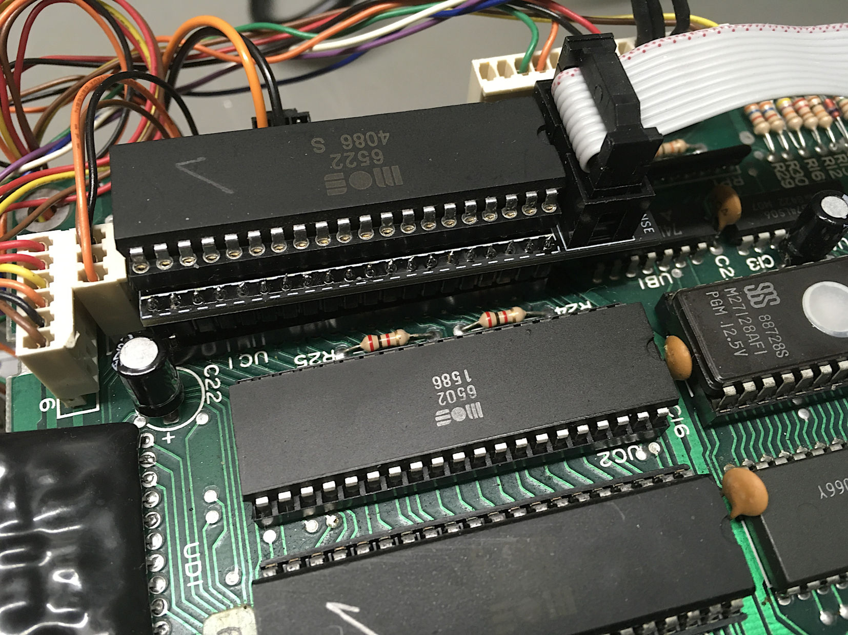

Figure : Installation in a 1541C

Due to a lack of a working 1541C, the adapter was installed in a 1541. Since it is not designed to fit into the 1541, a DIP40 socket was required to fit the adapter for the test. Closing the lid of the 1541 was not possible, but this is not withing the scope of this development.

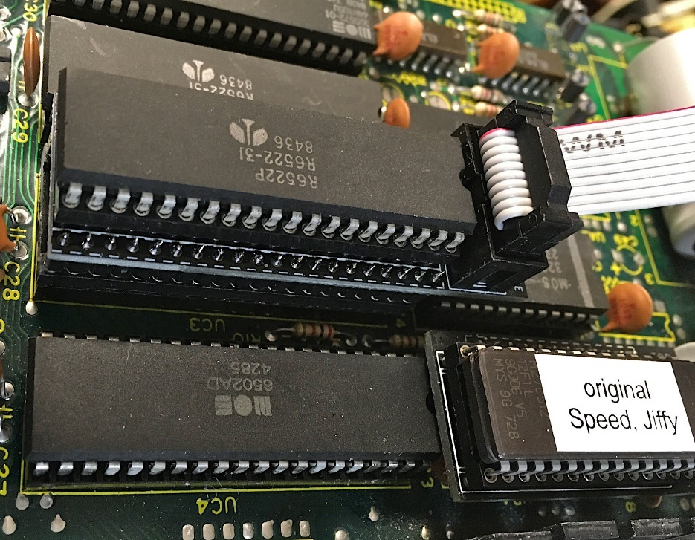

Figure 2: Installation in a 1541 for electrical testing

The game “Vengeance” was loaded from floppy disk with the parallel cable connected to the C64 via the User Port parallel adapter. This required 22.8 seconds.

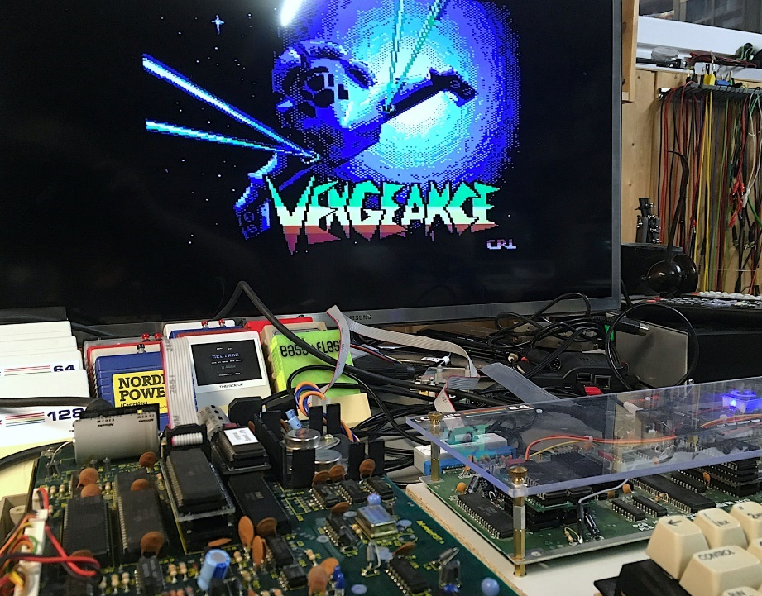

Figure : Loading Vengeance

Now, the parallel cable was disconnected and both SpeedDOS Kernals (1541 and C64) were replaced by the original Commodore Kernals.

Loading “Vengeance” required 160.2 seconds (7 times as long).

# Conclusion

The final test in a 1541C has still to be conducted, but the likelihood is close to 100%, that this will work. Probably, the jumper JP1 has to be opened.